**Software System**

Waste management system

**Features**

Features are listed below.  **High**, **Medium** and **Low** are used to indicate the importance of each feature.

|  |  |  |  |
| --- | --- | --- | --- |
| **Feature ID** | **Description** | **Priority** | **Requester** |
| **WM01** | Web based and accessible from devices (with internet connection) such as desktop, laptop, mobile and tablet PCs. | High |  |
| **WM 02** | Accessible only to authenticated and authorized users | High |  |
| **WM 03** | Employee data management for example:  personal details, training history, promotion history and so on.  It will also allow employee search and viewing employee list | High |  |
| **WM 04** | Report generation based on user needs. | Medium |  |
| **WM 05** | User management and auditing user activities | High |  |
|  |  |  |  |

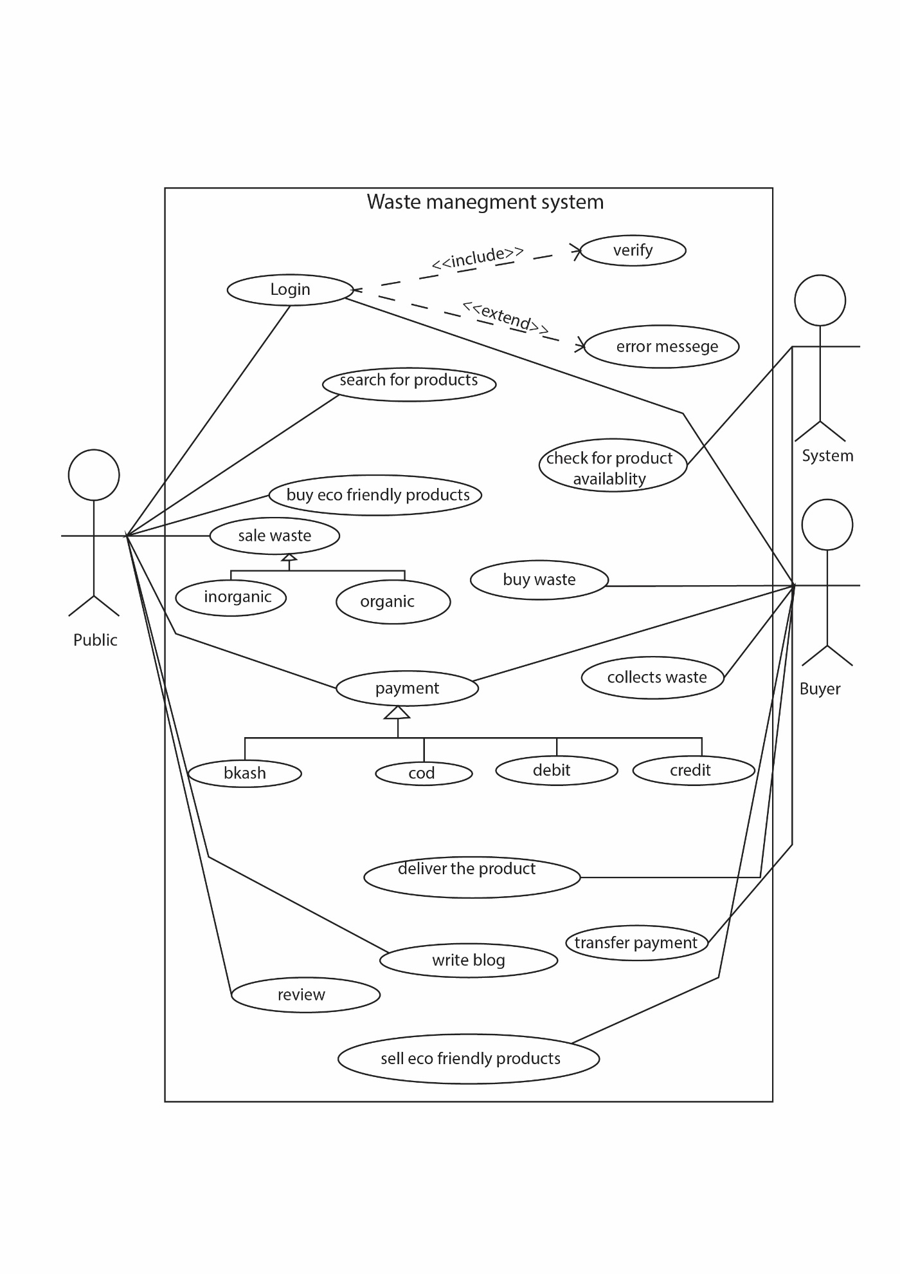

**Use Cases**

|  |  |
| --- | --- |
| **WM02 - Authentication and authorization** | |
| **WM02_UC01** - User authentication | |
| **Brief Description** | The user opens up the portal and the portal shows the login form for access. |
| **Pre-condition/s** | * User is not logged in already * User has an account in the system |
| **Priority** | High |
| **Actor/s** | Users of all classes. |
| **Main Success Scenario** | 1. User opens up the web portal 2. The system displays a login form 3. User enters his/her user id and password 4. The system matches user credentials against its date store 5. The system then redirects user to the appropriate page based on user class. |
| **Alternative Scenario** | * The system cannot find a match for the user and re-displays the login form with an error message. * The system runs into internal error (i.e. database unavailable) and notifies user and asks the user to contact administrator |
| **Notes/Questions** | Must need clarification on dashboard for each user type. |

|  |  |
| --- | --- |
| **WM03 – Waste management system** | |
| **WM03_UC01** - Add new employee | |
| **Brief Description** | User wants to add a new employee and the system displays form to add employee data. |
| **Pre-condition/s** | * User must be logged in * User must have authorization to add employee |
| **Priority** | High |
| **Actor/s** | ADMIN, MANAGER |
| **Main Success Scenario** | 1. The system displays a form with all the necessary fields required to collect employee information. These fields will be Name, Date of Birth, Present Address, Permanent Address, E-mail Id, Contact Number, Training Information, Promotion Information, Experience Information and so on. 2. The system automatically generates an Employee ID to the new employer. 3. The ‘must be filled’ fields are marked with a red asterisk. 4. If a ‘must be filled’ field is bypassed an immediate warning with a red text is displayed underneath the information box. 5. Authentication for email. 6. Authentication for contact number. 7. When all the information is put the system generates a successful operation message and updates all the information properly in the database. |
| **Alternative Scenario** | * The system is unable to store the information in database and generates operation not complete message. |
| **Notes/Questions** | The system will not store information from incomplete form. A form will be incomplete when all the ‘must be filled’ fields are not filled. |
|  | |
| **WM03_UC02** - View employee list | |
| **Brief Description** | The system will display employee information |
| **Priority** | High |
| **Actor/s** | ADMIN, MANAGER |
| **Main Success Scenario** | 1. The user can generate a list of employees based on different view requirement 2. The employee list will be displayed in a single organized page |
| **Alternative Scenario** | * The system is unable to extract employee information from the database and generates error message |
| **Notes/Questions** | The types of views must be mentioned |